**Air Canvas**

**Group Name: Python Thinkers**

**Group Members:**

|  |  |  |
| --- | --- | --- |
| **First name** | **Last Name** | **Student number** |
| Anto | Francis | C0825095 |
| Rupesh | Chandran | C0826779 |
| Volkan | Guney | C0831373 |
| Sachin | Sreekumar | C0825096 |

**Submission date: *April 23, 2022***

**Table of Contents**

**Abstract** 4

**1.** **Introduction** 5

**2.** **Literature Review** 6

**3.** **Challenges Faced** 7

**a.** **Finger detection** 7

**b.** **Captures pen up and pen down motion** 7

**c.** **Controlling the real-time system** 7

**4.** **Problem Definition & Proposed Solution** 8

**Proposed solution** 9

**5.** **Methods** 12

**a.** **Our Approaches** 12

**Using RGB Color Space** 12

**Using HSV Color Space** 13

**b.** **Algorithm** 14

**6.** **Result** 15

**7.** **Conclusion and Future Scope** 16

**8.** **References** 17

**List of Figures**

Figure 1: Workflow of the system 9

Figure 2: Result in RGB Color Space 12

Figure 3: Blue color HSV Detection 13

Figure 4: User Interface of the Application 15

# **Abstract**

Within the boundaries of Computer Vision, object identification is seen as a significant problem. Object tracking systems have gained popularity due to faster processing units, affordable and high-quality video cameras, and the demand for extracting data from videos. Generally, the video data extraction procedure has three main steps: identifying the object, finding its movement from frame to frame, and getting the object's behavior. Four issues are considered here: selecting a good representation of the object, selecting the features for tracking, detecting the object, and tracking the object.

The project takes advantage of this void by focusing on developing a motion-to-sketch converter that might be used as native computer application for smart devices that allow for writing in front of the camera frame. This application will use computer vision to track the colored marker on the fingertip in the video frames. Here Colour Detection and tracking are used to achieve the objective. A mask is created after the color marker is identified. Erosion and Dilation are the next steps in the morphological operations on the show that have been generated. The imperfections in the Mask are reduced by erosion, and the eroded primary Mask is restored further by Dilation.

# **Introduction**

The traditional sketching craft is overtaken by digital art in the digital age. Digital art means to the art forms that are expressed and transmitted in a digital manner. Digital manifestations are distinguished by their reliance on modern science and technology. Conventional art refers to the art form created way before digital art. From recipient to analysis, it can be divided into visual, audio, audio-visual, and imaginary audio-visual art forms, including literature, painting, sculpture, architecture, music, dance, drama, and other works of art. Digital art and conventional art are interdependent. Although social growth is not a result of the will of the people, the demands of human life are the primary driving force. Similar kind of situation happens in art. In the current scenario, digital art and conventional art forms are inclusive of the symbiotic state, so we need to understand the basic difference between digital art and classic art.

The traditional way of writing includes materials such as chalk, pen, paper, etc. The important aim of digital art is to build a system to write or sketch digitally. Digital art includes many writing ways like using a keyboard, touch-screen surface, digital pen, stylus, electronic hand gloves, etc. But in this system, we are using colored marker recognition using a machine learning algorithm using python programming.

## 

# **Literature Review**

1. **LED fitted finger movements**

The authors of [1] proposed a system in which an LED is put on a user's finger and tracked using a camera. The drawn character is compared to the one in the database. It identifies the alphabet that corresponds to the pattern that was drawn. It necessitates the attachment of a red LED pointed light source to the finger. Here, it is considered that no objects with the same color of the light are anywhere near it.

1. **Augmented Desk Interface**

[2] presented an augmented desk interface technique for interactivity. This technology employs a video projector and a charge coupled camera to allow users to control desktop apps with their fingertips. Each hand in this system performs a distinct task. The left-hand picks radial menus, while the right selects manipulable items. It accomplishes this through the use of an infrared camera. Because it is computationally expensive to determine the fingertip, this method creates search windows for fingertips.

## 

# **Challenges Faced**

## **Finger detection**

It's difficult to recognize a finger from an RGB image without it, as it would create a lot of noise. There is a high possibility that the application would detect multiple fingers and create noises on the screen. Hence, decided to go with a colored marker object in our hand.

## **Captures pen’s up and down motion**

Writing from above is done with a single RGB camera. Up and down pen movements cannot be tracked because depth detection is impossible. As a result, the complete trajectory of the fingertip is tracked, resulting in an outlandish image that the model would not recognize. Hence, we will have to find a colored device that would display light whenever required, or we would have to cover our marker whenever we don't need to draw things on the screen.

## **Controlling the real-time system**

Using hand gestures to change the system's current state necessitates in real time needs a great deal of coding attention. In addition, the user must be familiar with a variety of movements to control the strategy effectively.

## 

# **Problem Definition & Proposed Solution**

The project focuses on solving some significant problems mentioned below:

1. ***Infection precaution****:* In this covid era, it would be grateful to use a touch-free input system at places where the public would have to interact for various reasons.

2. ***People with hearing impairment****:* They communicate via sign language, even though we take hearing and listening for granted. Without a translator, most of the globe will not comprehend their feelings and emotions.

3. ***Paper wastage****:* We squander quite a large number of paper with writing, sketching, and other activities. Some fundamental facts include: one A4 size paper requires more than five liters of water on average, 93 percent of writing comes from trees, half percent of business waste is paper, 25% of landfills is paper, etc. Paper waste is terrible for the environment since it wastes water and forests and produces much garbage.

These problems can be swiftly resolved by using air writing. It will act as a useful tool for deaf or hard-of-hearing persons. Their handwritten text can be exhibited or transformed into speech by augmented reality (AR). You can write in the air fast and get back to work without being distracted. Furthermore, writing in the air does not necessitate the use of paper. Everything is kept on a computer.

## 

## **Proposed solution**

This computer vision project is an Air canvas that allows you to create on a screen by waving a finger with a colored tip or a basic-colored cap. For these computer vision projects, OpenCV came to the rescue. The proposed technology allows for natural human-system interaction, eliminating the need for an input device like stylus, gloves and so on for character entry.

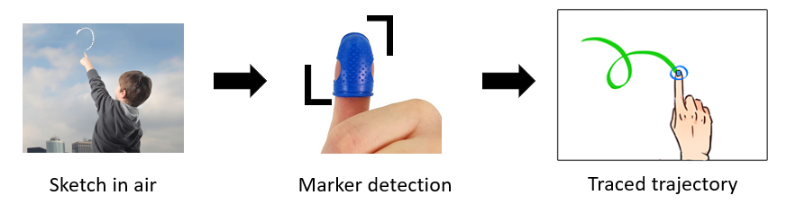

Figure : Workflow of the system

A colored marker detection model is required for this system. This project will be built utilizing OpenCV's computer vision techniques. Python is the preferred language because of its extensive libraries and simple syntax, although it can be done in any OpenCV supported language if the foundations are understood.

In order to perform this operation, color detection and tracking are used. A mask is created after the color marker is identified. Erosion and Dilation are the subsequent phases in the morphological operations on the Mask that has been constructed. The imperfections in the Mask are reduced by erosion, and the eroded primary Mask is restored further by Dilation.

Steps in detail:

**1. *Colour Tracking of Object at fingertip:*** In order to detect the colored marker at the tip of the finger, the input frame from the webcam is first transformed into the HSV color space. The function converts the received image to the HSV color space, which is an excellent choice for color monitoring. We will use the Trackbars to adjust the HSV values to match the color range of the colored object placed on our finger. We will obtain the real-time value from the trackbars and build a range after they are set up. This range is a NumPy array supplied to the inrange() method of openCV. This function develops the Mask on the colored object. This Mask is a binary picture with white pixels in the appropriate color locations.

**2. *Contour Detection of the Mask of Colour Object****:* Now that the Mask has been detected in Air Canvas, it is time to find its center point to Draw the Line. We use morphological techniques on the Mask to remove imperfections and make it easier to recognize contours.

**3. *Drawing the Line using the position of Contour:*** The idea behind this Computer Vision project will now be revealed; we will create a Python deque (A data Structure). The deque will save the position of the center point of contour on each subsequent frame, and we will utilize these points to draw a line with OpenCV drawing algorithms. We will use the contour's position to determine whether we want to click a button or draw on the sheet. Some of the buttons have been positioned on the top of Canvas; when the pointer enters their area, their method will be triggered. On the canvas, we have four buttons drawn with OpenCV.

* Clear: Which clears the screen by emptying the deques.
* Red: Change the marker to red color using a color array.
* Green: Change the marker to green color using a color array.
* Yellow: Change the marker to yellow color using a color array.
* Blue: Change the marker to a blue color using a color array.

Also, we will add a condition to capture that moment to avoid drawing when a contour is not detected.

4. ***Drawing the points****:* We will color all points on the positions stored in the deques.

## 

# **Methods**

## **Our Approaches**

We tried our various approaches and decided not to use a few of them because of feasibility issues. Here are a few methods we tried.

### **Using RGB Color Space**

Initially, we tried to implement this project using RGB color space. We used RGB values to detect the color of the marker. However, the object was not getting detected under different lighting conditions.

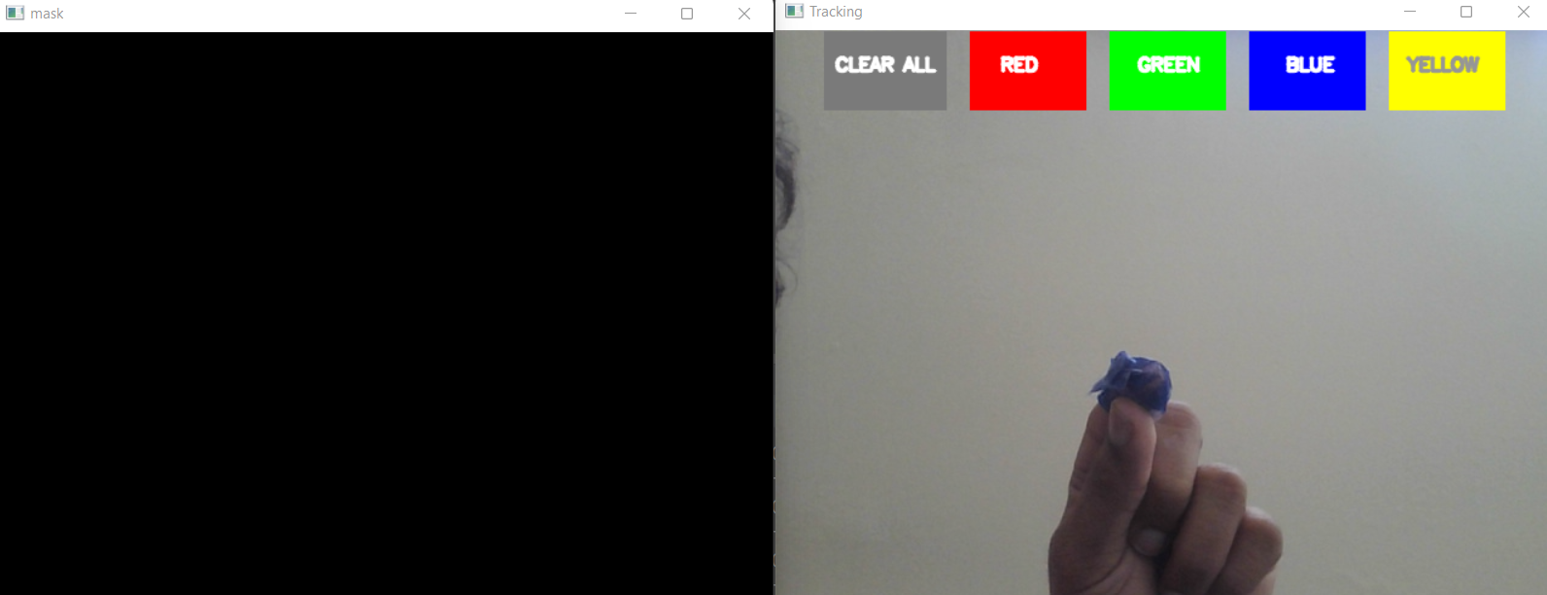

Figure : Result in RGB Color Space

The main limitation of RGB color space is that it does not work well when lighting changes or if there is a presence of any shadow in the visual. So, we did some research and figured out that HSV color space has better capabilities than RGB. If the HSV system detects a shadow on an object, then its Hue object will not be affected. Only the Saturation and Value components will be changed.

### **Using HSV Color Space**

Once we decided to use HSV color space for our project, we researched proper Hue Saturation Values for each of the colors. We did some trial and error methods to find out different variations in each color.

Figure : Blue color HSV Detection

Figure 3 shows how the blue color is getting captured in our system. Different various blue colors are captured, and created masks for each of them. Hence, we decided to go ahead with the HSV color approach.

## **Algorithm**

***STEP 1****:* Begin by reading the frames and converting them to HSV color space. (Colour detection is simple)

***STEP 2****:* Put the appropriate ink buttons on the canvas frame.

***STEP 3****:* Adjust the trackbar values to locate the colored marker's Mask.

***STEP 4****:* Use morphological techniques to pre-process the Mask. (Dilation and erosive erosion)

***STEP 5****:* Identify the contours, locate the middle point of the most significant shape, and store them in the queue for subsequent frames. (Points on the canvas are drawn using arrays.)

***STEP 6****:* Finally, plot the points saved in the queue on the frame and canvas.

# 

# **Result**

The most exciting aspect of our system is this. Writing entails a wide range of capabilities. As a result, the number of gestures utilized to manage the system is the same as the actions. Some of the features we included in our system are:

* The ability to track a specific-colored pointer.
* The user can draw in four different colors and easily switch between them.
* Able to rub the board from a single point on the screen's top.
* Once the application is started, there is no need to touch the computer.

Figure : User Interface of the Application

# 

We have uploaded our project files to <https://github.com/sachinsreekumar/AirCanvas>

# **Conclusion and Future Scope**

In this project, we created an Air canvas using OpenCV and Python. We learned about color detection and segmentation techniques, thresholding approaches, logical operations, and other image processing techniques throughout this assignment. On the other hand, the proposed methodology may be helpful, but it has one major flaw: color sensitivity. The presence of a background color that matches the marker's color can result in unintentional lines. This application could replace the conventional methods of drawing things on the screen. There are a few limitations to this system that can be improved in a later phase. This application could be made to run on top of other applications to write anything on that window. This could be useful in putting signatures on the screen digitally. Also, people who have little idea how to use a keyboard could make use of this application to write characters on the screen if this application is integrated with a character recognition model. The effectiveness of Air drawing or writing could be improved in the later years due to the advancement of Artificial Intelligence.

# 

# **References**

[1] Alper Yilmaz, Omar Javed, Mubarak Shah, "Object Tracking: A Survey," ACM Computer Survey. Vol. 38, Issue. 4, Article 13, Pp. 1-45, 2006

[2] Yuan-Hsiang Chang, Chen-Ming Chang, "Automatic Hand-Pose Trajectory Tracking System Using Video Sequences," INTECH, pp. 132- 152, Croatia, 2010

[3] Ayushman Dashz, Amit Sahuz, Rajveer Shringiz, John Gamboax Muhammad Zeshan Afzal, Muhammad Imran Malik, Sheraz Ahmedy and Andreas Dengely" AirScript Creating Documents in Air" 14th IAPR International Conference on Document Analysis and Recognition

(ICDAR) IEEEXplore2017

[4] Air-writing Recognition, Part 2: Detection and Recognition of Writing Activity in Continuous Stream of Motion Data Mingyu Chen, Ghassan AlRegib, Senior Member, IEEE, and Biing Hwang Juang, Fellow, IEEE.IEEE TRANSACTIONS ON HUMAN-MACHINE SYSTEMS.

[5] A Novel Human-3DTV Interaction System Based on Free Hand Gestures and a Touch-Based Virtual Interface by SHUN ZHANG AND SHI ZHOU ZHANG IEEE Sensors J., vol. 19, no.20, pp. 95049511, Oct. 2019.

[6] Dhak, B., Gupta, A., Gajbhiye, O., &amp; Chorghade, P. (n.d.). VIRTUAL TEACHING SYSTEM, 04(02).